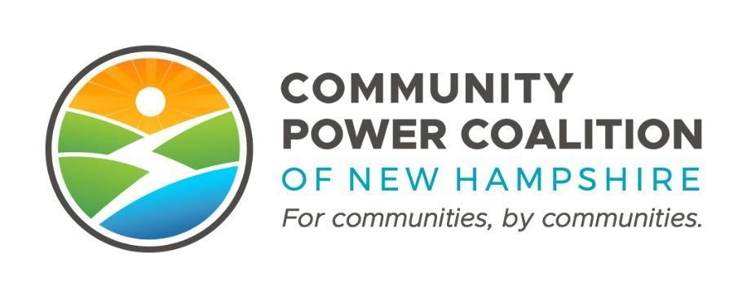
PUBLIC MEETING NOTICE

Regulatory & Legislative Affairs Committee
10:00 A.M. - June 16, 2023
14 DIXON AVE, SUITE 201
Concord, NH 03301

This meeting is open to the public pursuant to RSA 91-A.

The Community Power Coalition of New Hampshire is a non-profit corporation operating as a governmental instrumentality pursuant to a Joint Powers Agreement among a number of municipalities and counties, in accordance with NH RSA 53-A and RSA 53-E.
Additional information: https://www.cpcnh.org
Notice & virtual access: https://www.cpcnh.org/calendar

CPCNH Regulatory & Legislative Affairs Committee Meeting, 6/16/2023
AGENDA
- Welcome, Roll Call, Approve Minutes
- Review and discussion of relevant PUC dockets and DOE investigative proceedings. See the attached spreadsheet created by Clifton Below, “2023-06-12 NH PUC Proceedings and Companies Tracker.” Note that this document contains links to the dockets and proceedings.
- Discussion on how to move forward with the creation of a charter for the RLAC. Here are some sample policy documents collected by Henry Herndon that may be useful background:
A selection of California CPA JPA policy platforms:
- Clean Power Alliance Legislative and Regulatory Policy Platform
- East Bay Community Energy Legislative Program (and online bill tracker)
- California CPA trade association ("CalCCA") policy webpage.
In MA, the Cape Light Compact CPA JPA public advocacy webpage.

CPCNH's public advocacy webpage.

Also see attachment “CPCNH JPA as of 4-21-23 excerpted for RLAC” for charter context in the CPCNH JPA and by-laws.
- New business
- Adjournment

