PUBLIC MEETING NOTICE

**Member Outreach and Engagement Committee**

**10:00 A.M. Tuesday, May 9, 2023**

14 Dixon Ave, Suite 201

Concord, NH 03301

**This meeting is open to the public pursuant to RSA 91-A.**

The Community Power Coalition of New Hampshire is a non-profit corporation that operates as a governmental instrumentality pursuant to a Joint Powers Agreement between 27 municipalities and one county, in accordance with NH RSA 53-A and RSA 53-E.

Additional information: <https://www.cpcnh.org>

Notice & virtual access: <https://www.cpcnh.org/calendar>

Virtual Access: <https://us06web.zoom.us/j/86594684665?pwd=NFNXbS81SForb3RuWEhIaS9RbldGdz09> | Meeting ID: 865 9468 4665 | Passcode: 467234

**CPCNH Member Outreach and Engagement Committee, 5/9/23**

**AGENDA**

1. Welcome & Housekeeping
   1. Rollcall, quorum confirmation (1/3 of 9 → 3), consensus on agenda (**See** **Attachment 1: New Committee Description and Members**)
   2. Approval of [4/11/23 Draft Minutes](https://drive.google.com/drive/u/0/folders/1Wv8KjF_aAJx6oALbf5WH2-SiE3qVnDBk) (**Action**)
2. New Member Orientation
3. PUC Complaint Update
4. Member Services Update
5. Member Mentor Update
6. Planning for Member Outreach and Engagement Committee thru April 2024 (**See Attachments 2: Revision of Committee and 3: Ideas for Meetings/Events**)
7. Next meeting and adjourn

**Attachment 1: New Committee Description and Members**



**Attachment 2: Revision of Committee**

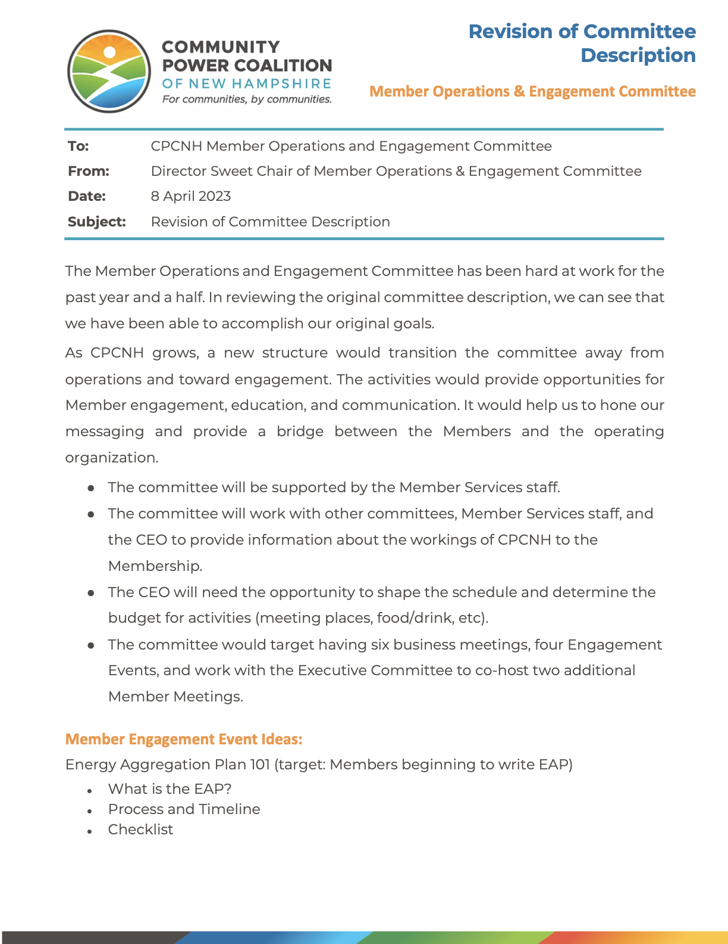

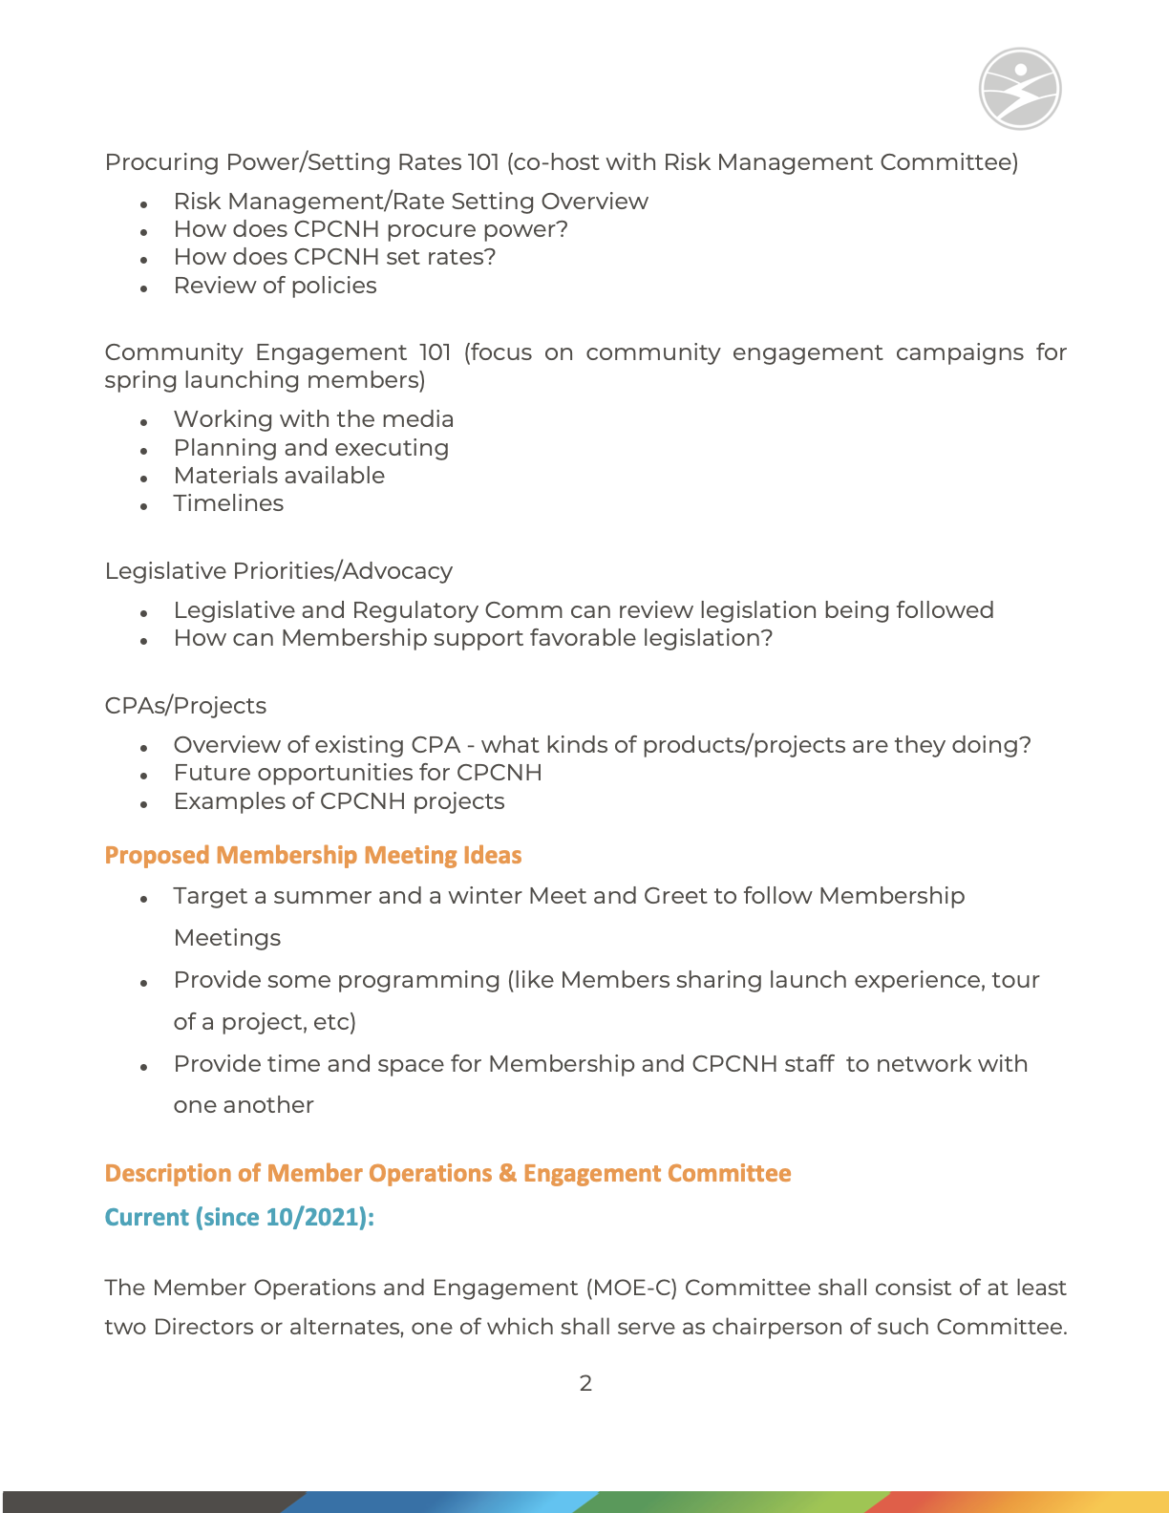

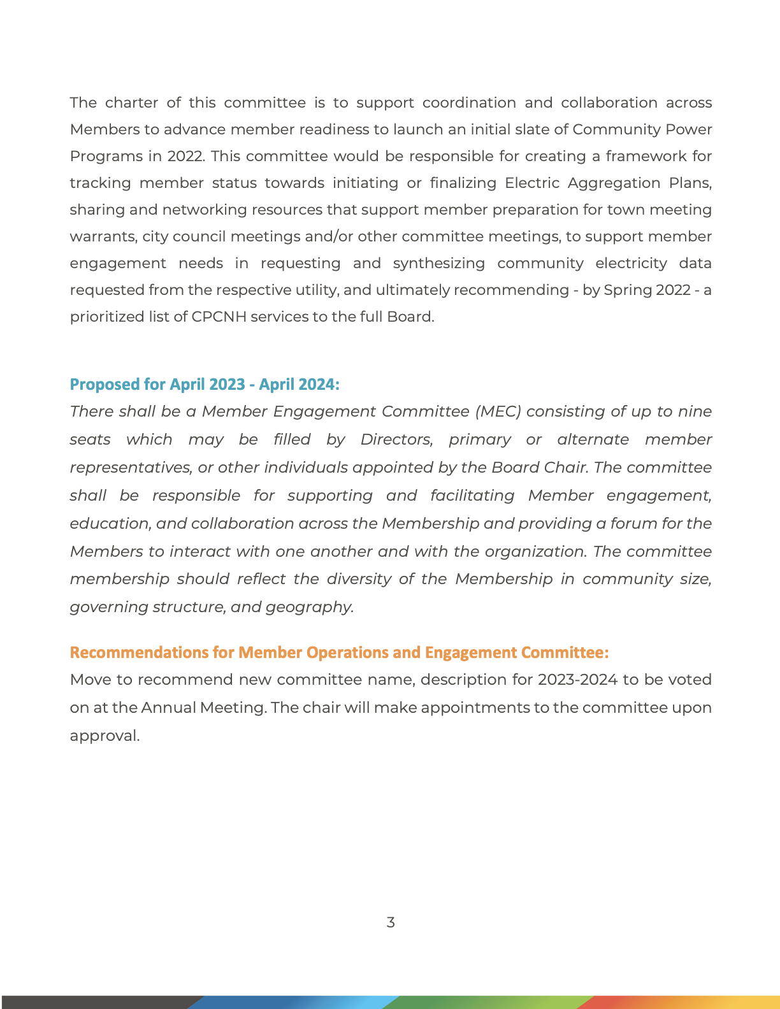

**Attachment 3: Ideas for Meetings/Events**

