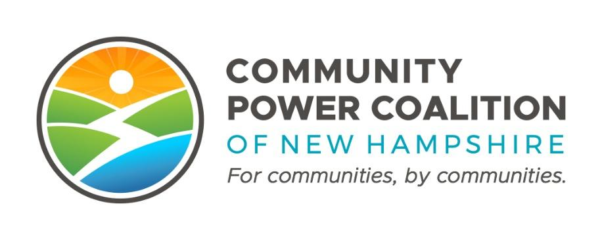
PUBLIC MEETING NOTICE

Member Operations and Engagement Committee
10:00 A.M. Tuesday, January 10, 2023
Dover City Hall, Council Conference
288 Central Ave., Dover, NH 03820

This meeting is open to the public pursuant to RSA 91-A.

The Community Power Coalition of New Hampshire is a non-profit corporation that operates as a governmental instrumentality pursuant to a Joint Powers Agreement between 18 municipalities and one county, in accordance with NH RSA 53-A and RSA 53-E.
Additional information: https://www.cpcnh.org
Notice & virtual access: https://www.cpcnh.org/calendar
Virtual Access: https://us06web.zoom.us/j/86594684665?pwd=NFNXbS81SForb3RuWEhIaS9RbldGdz09 | Meeting ID: 865 9468 4665 | Passcode: 467234

CPCNH Member Operations and Engagement Committee, 1/10/23
AGENDA
- Welcome & Housekeeping
  - Rollcall, quorum confirmation (1/3 of 10), consensus on agenda
  - Approval of minutes from 12/6/22 (Action by Unanimous Consent)
- Planning for 2023
  - Mapping Out 2023, Month-by-Month
    - Wave 1 – Launch
    - Wave 2 – EAP Approvals
    - Member Candidates/Recruiting: CENH-hosted Forum 2/23/23
    - Onboarding New Members
    - Wave 3 – EAP Process
  - Quarterly Focus – 1 meeting/quarter as Coalition-wide presentation/Q&A
- Community Power Public Engagement Campaigns (Attachment to follow)
  - Timeline, Key Messages, Actions
  - Menu of Resources
- Member Services – update from Clean Energy NH
  - Public Engagement planning
  - Media Strategy
- Annual Meeting
- Adjourn – next meeting Tuesday 2/14, 10:00 am (Action by Unanimous Consent)

