Coalition Messaging Document

Community Power
Public Engagement Planning
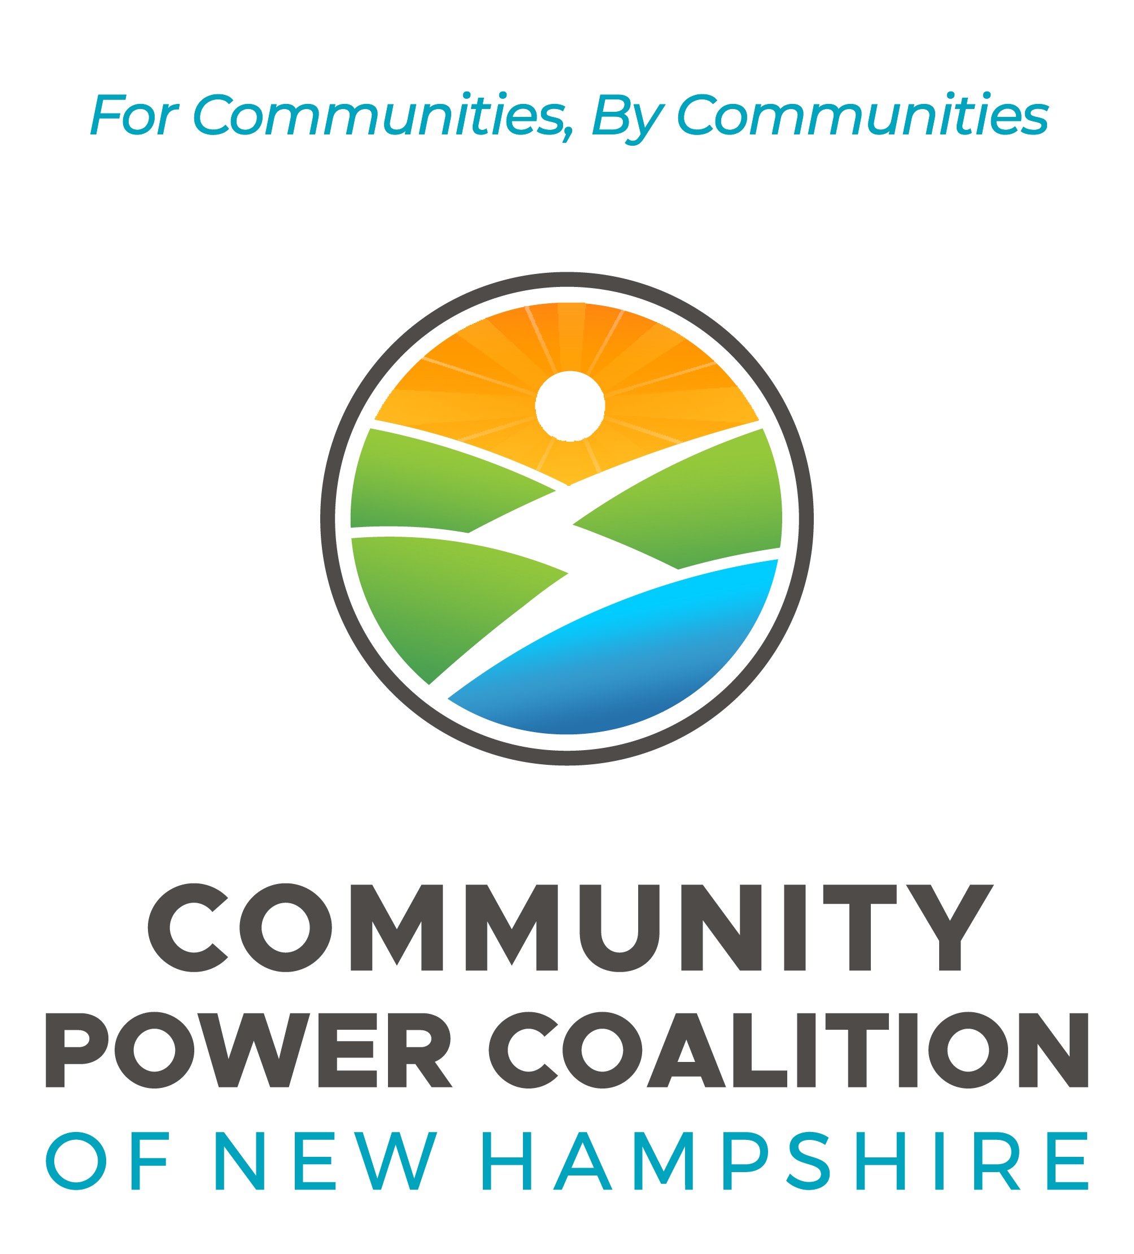
DRAFT DATE: October 2, 2022
CONTACT: HENRY@CPCNH.org

MISSION & VALUES 1
MISSION 1
VALUES 1
MESSAGES 2
KEY THEMES FOR CUSTOMERS 2
Choices for Customers 2
Lower Costs and Rate Stability 2
Local Control Over Energy Decisions 2
Renewable Energy, Resilience and Innovation 3
THE COALITION – STRONGER TOGETHER 3
Shared Technical Expertise 3
Transparency and Accountability 3
Economy of Scale 4
Statewide Public Advocacy 5

MISSION & VALUES

MISSION

Our mission is to foster resilient New Hampshire communities
by empowering them to realize their energy goals.

The Coalition creates value for our Community Power member municipalities by jointly contracting for services, developing projects and programs together, educating and engaging the public, and advocating for communities and customers at the Legislature and Public Utilities Commission.

VALUES
In carrying out its activities, the Coalition is guided by the following values:
​​
- Embody an inspiring vision for New Hampshire’s energy future.
- Support communities to reduce energy costs and pursue economic vitality by harnessing the power of competitive markets and innovation.
- Support communities to implement successful energy and climate policies and to promote the transition to a carbon neutral energy system.
- Balance the interests of member communities who are diverse in demographics, geography and their energy goals.
- Use our shared expertise, leadership and skills to educate, empower and build the capacities of our members.
- Help communities demystify the power sector to make informed decisions.
- Facilitate collaboration and teamwork by championing diversity, equity and inclusion of people and communities of all kinds.

MESSAGES

KEY THEMES FOR CUSTOMERS

Choices for Customers
- Community Power offers customers a menu of options, allowing them to prioritize lower costs, clean energy, innovative products and services, or some combination thereof.
- Community Power is voluntary – any customer may switch back to the utility or a supplier of their choosing at any time, without penalty.
- Community Power replaces the utility company as the “default” supply option, giving customers more choices for energy supply.

Lower Costs and Rate Stability
- Community Power presents an opportunity to lower and stabilize energy costs for customers.
- Community Power programs have an advantage over regulated utilities in that they can participate freely in the market, choose to time power purchases when market pricing is favorable, and manage a diverse power portfolio actively over time.
- Investor-owned utilities are regulated and required to purchase power twice a year at set times, regardless of pricing in the market, which can result in higher costs.
- Pooling the buying power of our community’s collective energy users creates an economy of scale and can lower procurement costs.
- Community Power programs in other states have demonstrated an ability to provide electricity supply at rates that are lower than or competitive with default utility rates.
- Our Community Power Plan states that the program will only launch if it can initially offer default residential electric rates that are lower than or competitive with the utility rate.
- Our Community Power program adheres to best practices in energy risk management and allows for accrual of financial reserves to maintain stable rates over time.

Local Control Over Energy Decisions
- Community Power democratizes energy decision-making to the community level.
- Community Power lets cities and towns decide how to prioritize energy decisions, instead of leaving those decisions to investor-owned utilities or state regulators.
- To launch Community Power, a municipality or county establishes a public committee to develop a Plan, holds public hearings and gathers public input, and brings that Plan for a vote of adoption by its Legislative Body (e.g., Town Meeting or City/Town Council vote).

Renewable Energy, Resilience and Innovation
- The shared buying power and economy of scale of Community Power programs can create cost-effective opportunities to contract for development of new, local renewable energy and battery storage projects as part of the energy portfolio.
- Community Power opens the door for power sector innovation by offering products and programs to enable customer adoption of new technologies and behaviors that shift energy usage away from high-cost times. Examples include Time-of-Use rates, new net metering options, and battery storage opportunities.

THE COALITION – STRONGER TOGETHER

Shared Technical Expertise
- The Coalition conducted a competitive solicitation for services and credit support on behalf of members and is now negotiating contracts — with Ascend Analytics, Calpine Energy Solutions, River City Bank, and Clean Energy NH — for $750,000 in startup funding, ~$8.5 million in credit support, and up to ~$9 million in professional services to operate the power agency and expand the Coalition’s membership over the next three years.
- The Coalition’s team of vendors is shaping up to encompass a very deep bench of energy professionals and experts from both the local and national pool of solicitation respondents.
- The Coalition is additionally supported by outside General Counsel and two professional consultants.
- CPCNH has issued a solicitation for Executive Search Services and aims to hire a qualified CEO at the start of 2023.
- The Coalition helps members streamline the process for authorizing Community Powers locally. Through the Coalition, Members gain access to templates, technical experts, peer leaders, and other resources so they need not reinvent the wheel.
- The Coalition provides comprehensive services to launch and operate their Community Power programs.

Transparency and Accountability
- The Coalition is governed “by communities, for communities.”
- The Coalition is a public power agency, incorporated as a government instrumentality and non-profit.
- The Coalition is led by a Board of Directors, six committees of the Board, and an Officer team of elected officials, staff, and volunteers appointed by each of our local municipal members.
- As of October 2022, the Coalition has held over 80 public meetings of its Board and committees. Board and committee meetings of the Coalition are open to the public and subject to New Hampshire’s Right-to-Know law.
- The Board and executive team bring great breadth and depth of experience to the organization with professional backgrounds that support the Coalition’s mission.
 |  | Director | Alternate
City of Lebanon | Chair | Clifton Below | Greg Ames
City of Dover | Vice Chair | Christopher Parker | Jackson Kaspari
Town of Enfield | Treasurer | Kimberly Quirk | Jo-Ellen Courtney
City of Nashua |  | Doria Brown
Cheshire County |  | Terry Clark | Chris Coates
City of Portsmouth |  | Kevin Charette | Peter Rice
Town of Canterbury |  | Kent Ruesswick | Howard Moffett
Town of Durham |  | Mandy Merrill | Nat Balch
Town of Exeter |  | Nick Devonshire | Julie Gilman
Town of Hanover |  | April Salas | Peter Kulbacki
Town of Harrisville |  | Andrea Hodson | Andrew Maneval
Town of Hudson |  | Craig Putnam | Kate Messner
Town of New London |  | Jamie Hess | Tim Paradis
Town of Newmarket |  | Toni Weinstein | Steve Fournier
Town of Pembroke |  | Matthew Miller | Jackie Wengenroth
Town of Peterborough |  | Steve Walker | Danica Melone
Town of Plainfield |  | Evan Oxenham | Steve Ladd
Town of Rye |  | Lisa Sweet | Howard Kalet
Town of Walpole |  | Paul Looney | Dennis Marcom
Town of Warner |  | Clyde Carson | George Packard
Town of Webster |  | Martin Bender | David Hemenway
Town of Wilmot |  | William Chaisson

Economy of Scale
- The Coalition’s twenty-two current municipal members represent approximately 20% of New Hampshire’s population.
- At full enrollment of its current membership, the Coalition will serve ~110,000 customer accounts, provide ~900,000 megawatt-hours (MWh) of electricity, and produce revenues of up to ~$365 million per year (assuming retail pricing based on default utility rates in the current year).
- Over 30 additional local governments have expressed interest in joining the Coalition, which would increase representation to ~50% of New Hampshire’s population. The Coalition anticipates onboarding many new cities and towns as members over the coming months and years.
- The Coalition empowers members to participate in joint power solicitations and development of local projects if they so choose.
- The Coalition is positioned to become the largest default supplier of electricity in New Hampshire, as illustrated in the graphic below:
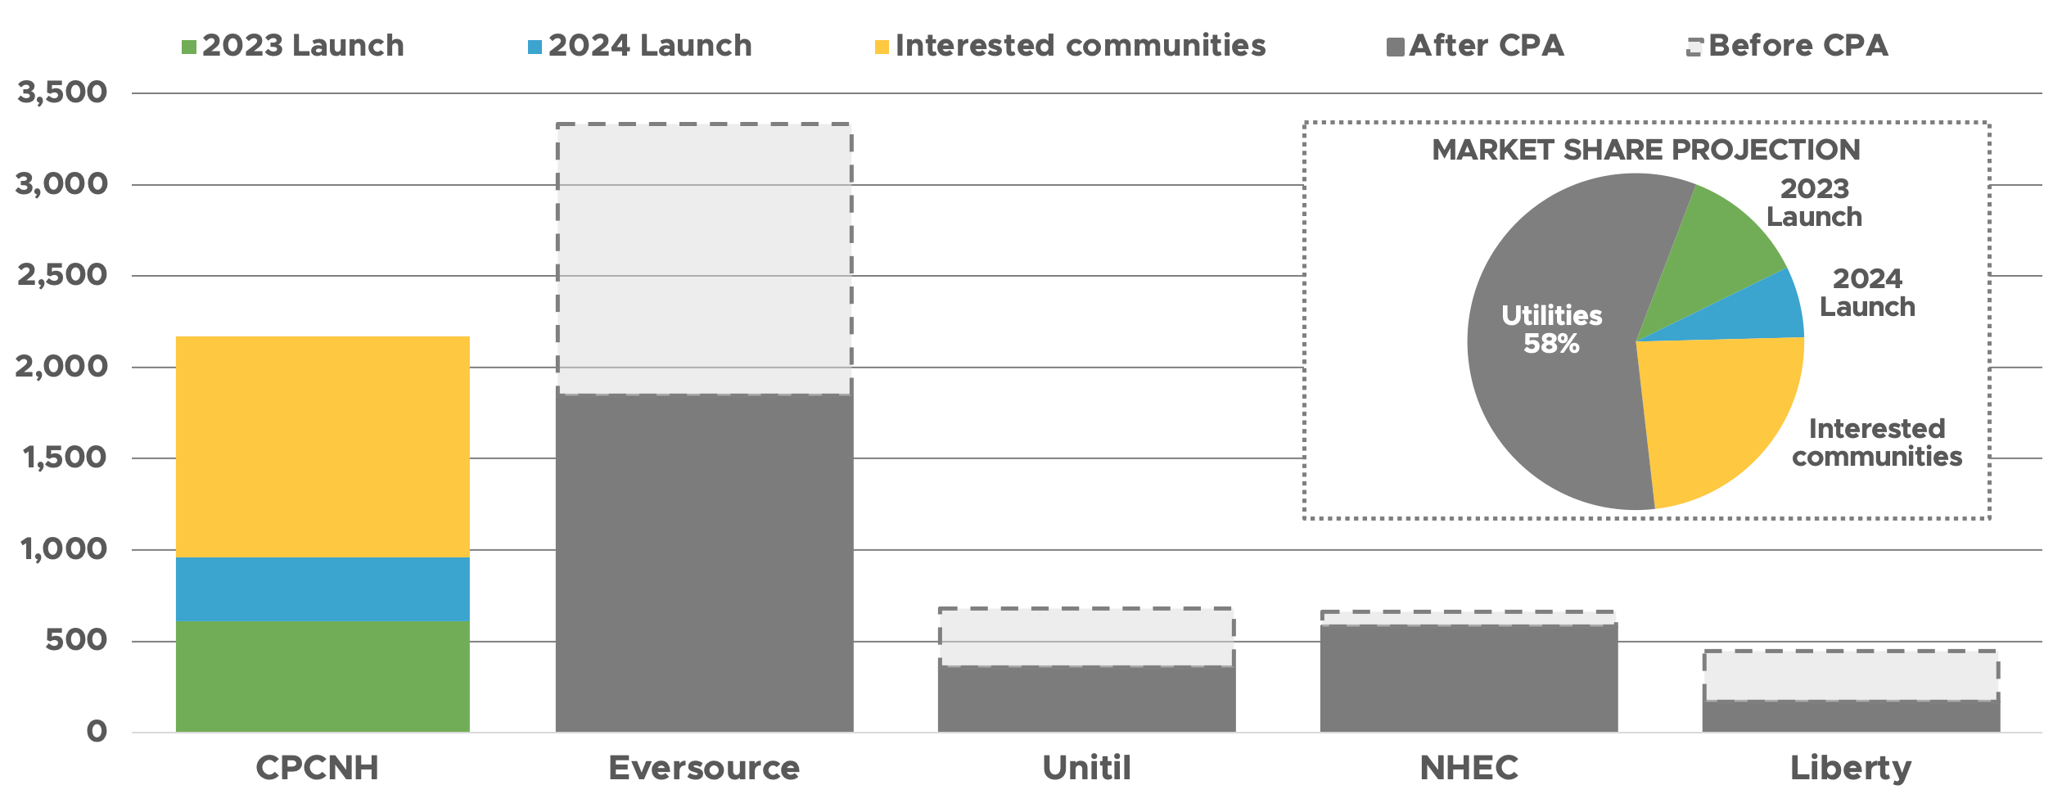

Statewide Public Advocacy
- The Coalition empowers members to speak with one voice at the Legislature and Public Utilities Commission on public advocacy issues related to energy and Community Power.
- Coalition leaders include former legislators and energy policy experts, including those primarily responsible for drafting the Community Power Act and the regulatory rules governing Community Power programs, and shepherding these policies into existence.
- The Coalition has a demonstrated its ability to shape public policy and advance consumer interests through grassroots, media and legislative advocacy leadership.
- New Hampshire’s updated Community Power law is a bipartisan policy designed to further evolve and enhance the economic efficiency of the State’s electric power industry. The Legislature’s intent was to encourage voluntary, cost effective and innovative solutions to local needs.

