PUBLIC MEETING NOTICE

**Member Operations and Engagement Committee**

**10:00 A.M. Tuesday, April 11, 2023**

14 Dixon Ave, Suite 201

Concord, NH 03301

**This meeting is open to the public pursuant to RSA 91-A.**

The Community Power Coalition of New Hampshire is a non-profit corporation that operates as a governmental instrumentality pursuant to a Joint Powers Agreement between 27 municipalities and one county, in accordance with NH RSA 53-A and RSA 53-E.

Additional information: <https://www.cpcnh.org>

Notice & virtual access: <https://www.cpcnh.org/calendar>

Virtual Access: <https://us06web.zoom.us/j/86594684665?pwd=NFNXbS81SForb3RuWEhIaS9RbldGdz09> | Meeting ID: 865 9468 4665 | Passcode: 467234

**CPCNH Member Operations and Engagement Committee, 4/11/23**

**AGENDA**

1. Welcome & Housekeeping
   1. Rollcall, quorum confirmation (1/3 of 8 → 3), consensus on agenda
   2. Approval of [2/7/23 Draft Minutes](https://drive.google.com/drive/u/0/folders/1Wv8KjF_aAJx6oALbf5WH2-SiE3qVnDBk) (3/7/23 meeting was canceled)(**Action**)
2. Member Services Update
   1. Wave 1, Wave 1+, Wave 2, New Members (Henry)
   2. Opt-up campaigns?
   3. Member Mentors - Plan meeting time for next steps
3. Clean Energy NH Update
   1. Member Candidates - Prioritized list
   2. Update on Working Activities
4. Member Operations and Engagement Committee April 2023-2024
   1. Proposal 2023-2024 Member Engagement Committee (Attachment 1 below)
   2. Interest for next year
   3. Consideration of Member Services staffing proposal (Attachment 2 below)
5. Adjourn - Next meeting Tuesday 5/9/23, 10:00 am

**Attachment 1: Revision of Committee**

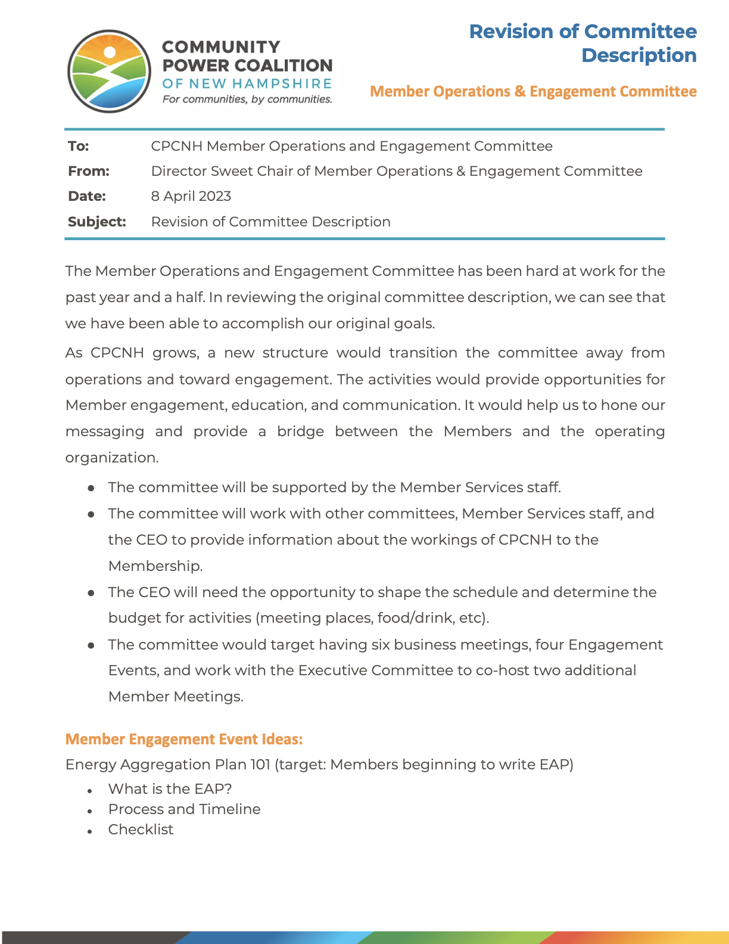

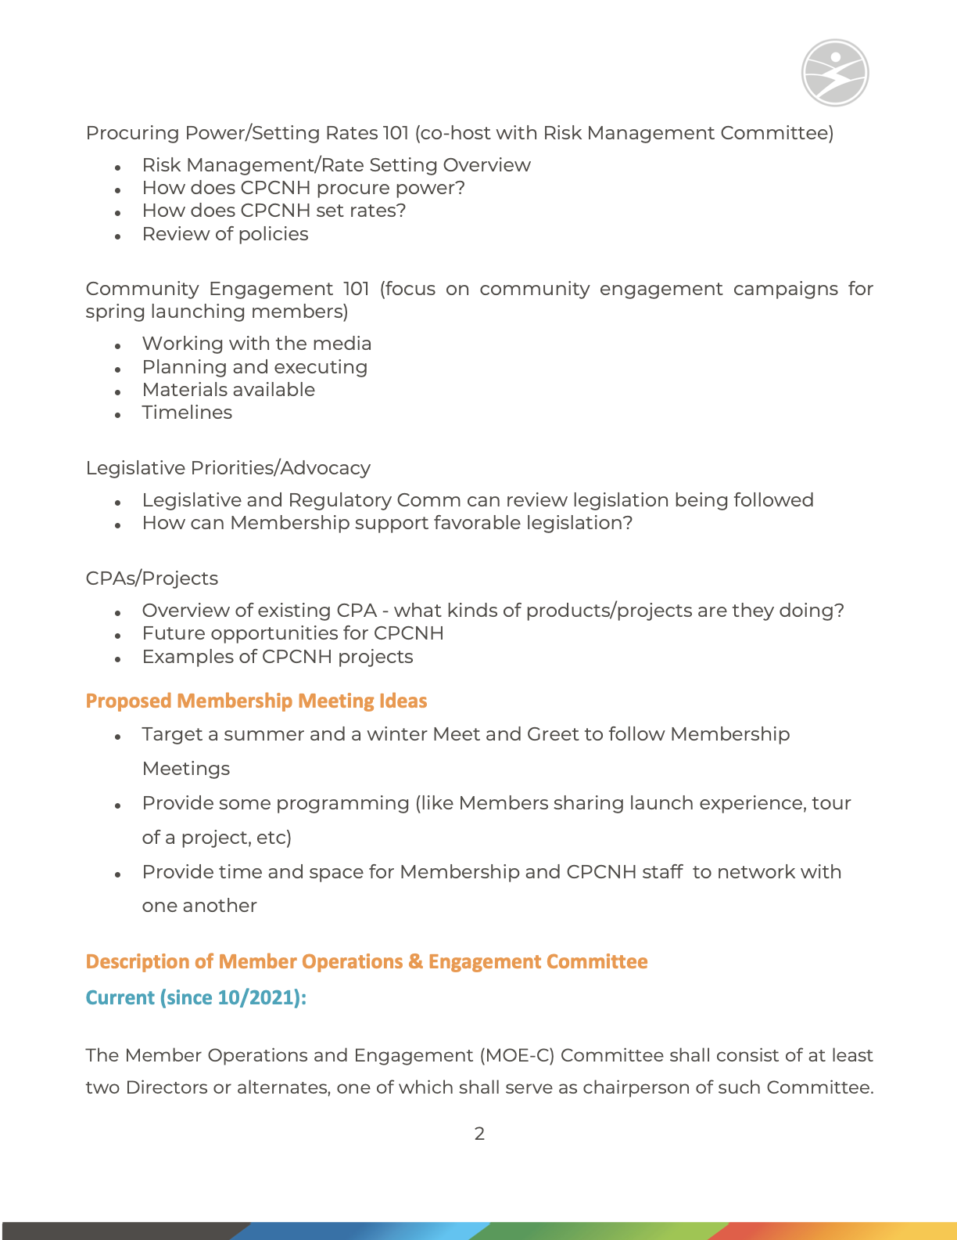

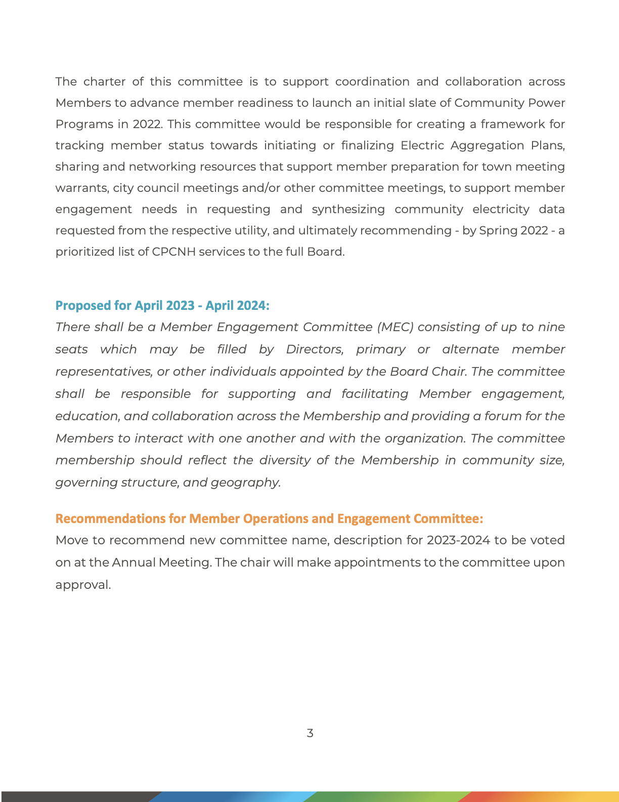

**Attachment 2: Proposal for New Position**

