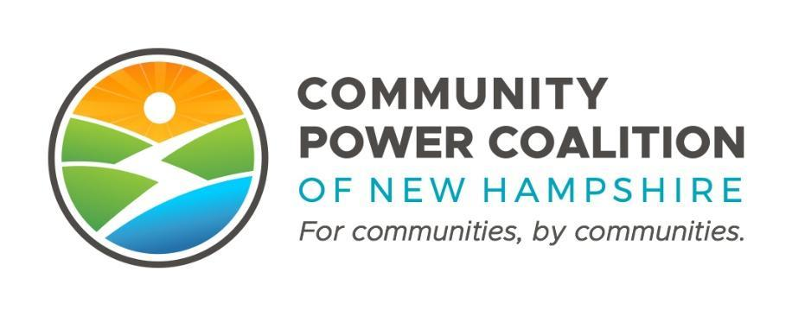
PUBLIC MEETING NOTICE

Member Operations and Engagement Committee
10:00 A.M. Tuesday, February 7, 2023
14 Dixon Ave, Suite 201
Concord, NH 03301

This meeting is open to the public pursuant to RSA 91-A.

The Community Power Coalition of New Hampshire is a non-profit corporation that operates as a governmental instrumentality pursuant to a Joint Powers Agreement between 27 municipalities and one county, in accordance with NH RSA 53-A and RSA 53-E.
Additional information: https://www.cpcnh.org
Notice & virtual access: https://www.cpcnh.org/calendar
Virtual Access: https://us06web.zoom.us/j/86594684665?pwd=NFNXbS81SForb3RuWEhIaS9RbldGdz09 | Meeting ID: 865 9468 4665 | Passcode: 467234

CPCNH Member Operations and Engagement Committee, 2/7/23
AGENDA
- Welcome & Housekeeping
  - Rollcall, quorum confirmation (1/3 of 10), consensus on agenda
  - Approval of 1/10/23 Minutes (Attachment 1) (Action)
  - Review of MOEC Board Report (attached below)
- Community Power Campaigns
  - Final Printed Materials (Handouts, Posters) (Attachment 2)
  - Websites Update
  - Open Forum for Campaigners
- 2/23/23 Community Power Forum | Planning for Member-Mentors
  - Member-Mentors Survey (Attachment 3)
  - Review Draft Agenda / Format (Attachment 4)
  - Discuss training resources for Member-Mentors
    - Community Power Checklist
    - Community Power 101 Presentation
    - Messaging document/FAQs
- Enrollment Mailer Design Review and Input (Attachment 5)
  - Review draft copy
  - Review 3 printing options
- 2023 Calendar for meetings (Attachment 6)
- Adjourn - Next meeting Tuesday 3/7/23, 10:00 am

