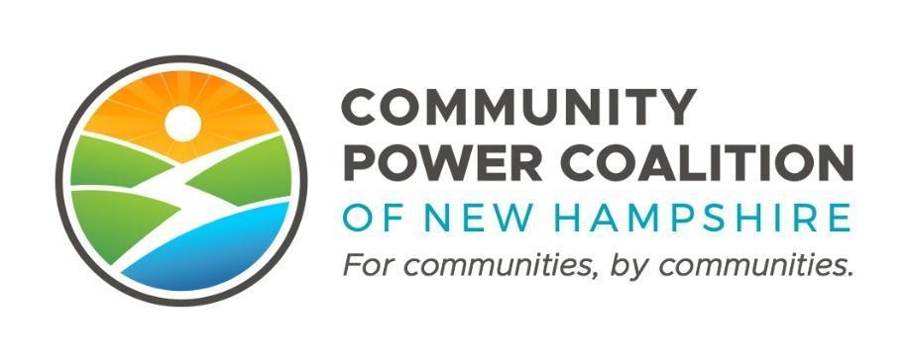
PUBLIC MEETING NOTICE
Member Outreach and Engagement Committee
10:00 AM– 12:00 PM Tuesday, October 10, 2023
14 Dixon Ave, Suite 201
Concord, NH 03301

This meeting is open to the public pursuant to RSA 91-A.

The Community Power Coalition of New Hampshire is a non-profit corporation that operates as a governmental instrumentality pursuant to a Joint Powers Agreement between 27 municipalities and one county, in accordance with NH RSA 53-A and RSA 53-E.
Additional information: https://www.cpcnh.org
Notice & virtual access: https://www.cpcnh.org/calendar
Virtual Access: https://us06web.zoom.us/j/86594684665?pwd=NFNXbS81SForb3RuWEhIaS9RbldGdz09 | Meeting ID: 865 9468 4665 | Passcode: 467234

CPCNH Member Outreach and Engagement Committee, 10/10/23
There shall be a Member Outreach and Engagement Committee (MOEC) consisting of up to twelve seats which may be filled by Directors, primary or alternate member representatives, or other individuals appointed by the Board Chair. The committee shall be responsible for supporting and facilitating Member engagement, education, and collaboration across the Membership, present and future, and providing a forum for the Members to interact with one another and with the organization. The committee membership should reflect the diversity of the Membership in community size, governing structure, and geography.
AGENDA
- Welcome & Housekeeping
  - Rollcall, quorum confirmation (1/3 of 9 → 3), consensus on agenda
  - Approval of 9/12/23 draft minutes (Action)

- Member Services Update & Media Strategy — 10:10 am – 10:30 am
  - Report from Member Services Director / Team
  - Possible November agenda topics
    - Member Reporting – Required and Desired
    - Member Communications folder
    - OPERATE phase
    - Targets for growth of membership

- LAUNCH Workshop 10:30 am – 12:00 pm
- Launch Authorizations (Policies for Rates, Risk, Reserves, and Data Protection; Cost Sharing Agreement and Member Services Contract)
- Working Timeline & Milestones for the Wave 2 Launch
- Strategies & Action Plans for Public Engagement

- Adjourn, next meeting November 14

