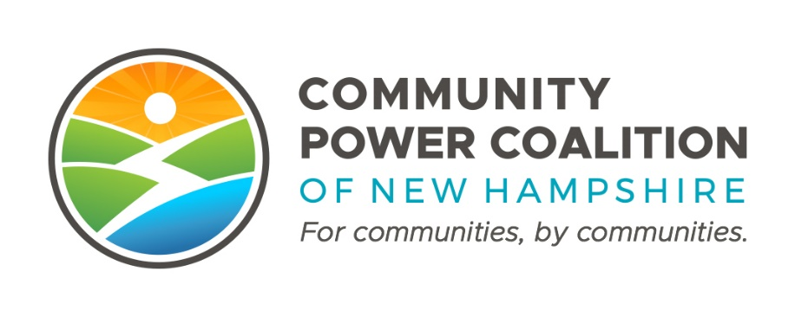
PUBLIC MEETING NOTICE

Member Operations and Engagement Committee
10:00 A.M. Tuesday, November 1, 2022
Dover City Hall, Council Conference
288 Central Ave., Dover, NH 03820

This meeting is open to the public pursuant to RSA 91-A.

The Community Power Coalition of New Hampshire is a non-profit corporation that operates as a governmental instrumentality pursuant to a Joint Powers Agreement between 18 municipalities and one county, in accordance with NH RSA 53-A and RSA 53-E.
Additional information: https://www.cpcnh.org
Notice & virtual access: https://www.cpcnh.org/calendar
Virtual Access: https://us06web.zoom.us/j/86594684665?pwd=NFNXbS81SForb3RuWEhIaS9RbldGdz09 | Meeting ID: 865 9468 4665 | Passcode: 467234

CPCNH Member Operations and Engagement Committee, 11/1/22

AGENDA
- Welcome & Housekeeping
  - Rollcall, quorum confirmation (1/3 of 10), consensus on agenda
  - Approval of 2022-10-11_CPCNH Member Operations and Engagement Committee DRAFT Minutes draft (Action by Unanimous Consent)
- Updates: EAP Adoption and Approval process tracker; JPA amendment
  - EAC Registration & Data Requests Memo
  - Update on Risk Management Committee + Ascend Progress & Timeline for Key Policies and Agreements (Cost Sharing Agreement + Energy Risk Management, Rates and Reserves Policy)
    - 11/15/22 RMC Forum for Potential Wave #1 Members
- Introducing Clean Energy NH, Member Services Vendor
  - Welcome Gina Blus, Energy Circuit Rider Program Director
  - Update on Contract Status (Target 11/17/22 Board Meeting Approval)
  - Pre-Contract Work Plan #1 (10/25/22 - 11/25/22) (ATTACHMENT in email)
    - Public Engagement Planning Resources, Media Kit, Member Media Training; Logos & Websites; Messaging Document; etc.
- Next MOEC Meeting: Tuesday December 6
- Adjournment (Action by Unanimous Consent)

