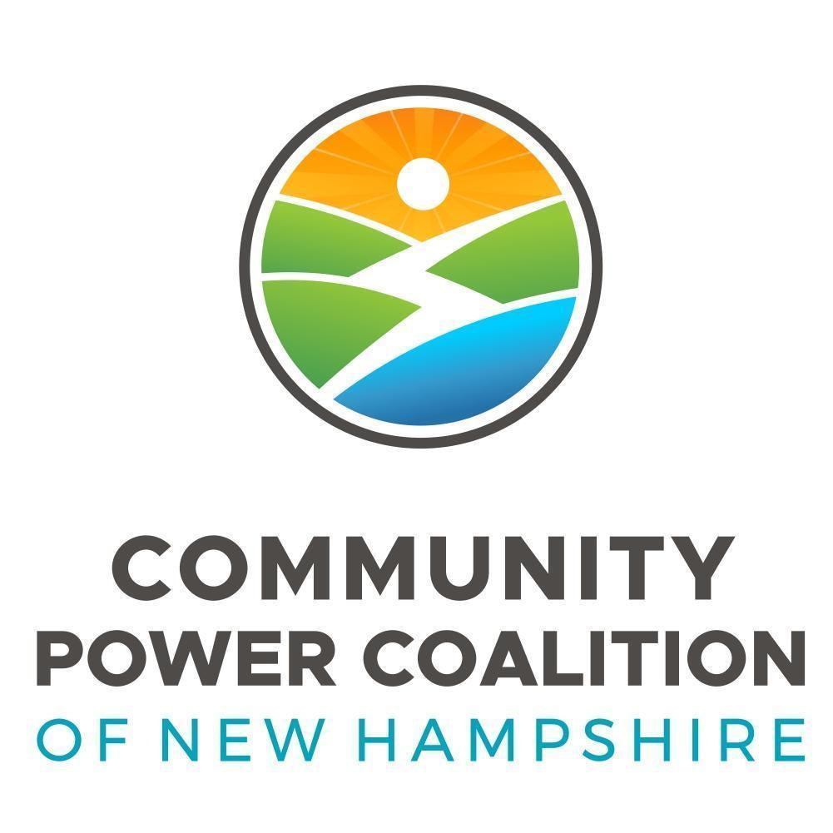 | Governance Committee DRAFT Minutes
 | Meeting Type: | Regular Meeting
 | Meeting Location: | Second Floor Conference Rm, County Hall, 12 Court Street, Keene NH
 | Meeting Date: | Monday, March 18, 2024
 | Meeting Time: | 10:15 a.m.

Members, attending in person | Others, attending virtually | Members, absent
- Committee Chair, Andrea Hodson Board Director Harrisville  - Terry Clark, Board Director, Cheshire County  - Andrew Maneval, Member Representative, Harrisville  - Mark Terry, Member Representative, Westmoreland | - Joe Lamattina, Board Director, Newmarket  Guests  - Brian Callnan, CPCNH CEO  - Bobbi-Jo Michael, CPCNH Director of Administration  - Lisa Sweet, Rye | - April Salas, Board Director, Hanover

Proposed Agenda
- Welcome, Roll Call
- Approve Agenda and 2/27 Meeting Minutes
- Election ballot preview for Board’s 3/28 meeting packet
- Annual Governance report
- Other Business and Next Meeting
- Adjournment
Welcome, Agenda, and February 19 Meeting Minutes. GovCom Chair, Andrea Hodson, called the meeting to order at 10:15am, establishing an in-person quorum.
Member Representative Terry moved to approve the agenda as presented., and the February 19 meeting minutes as prepared. Member Representative Maneval seconded the motion. Motion passed by unanimous consent.
Director Clark moved to approve the February 19 meeting minutes as prepared. Member Representative Terry seconded the motion. Motion passed by unanimous consent.
Member Representative, Maneval asked to clarify his intent in the minutes regarding his thoughts around a member running for a three-year term with the knowledge that they would only be planning to serve for one year.

- Paul Looney, current Director on the CPCNH Board, joined us to share that he is not interested in running for a three-year term as a Board Director, and wishes to be removed from the ballot that will be circulated to the membership a week from today.
- CPCNH CEO Brian Callnan shared that Charles (Chuck) Willing, a representative from the City of Concord, asked if and how Concod could have one of their representatives run for a seat on the Board of Directors. Callnan informed Willing that if they had a Primary or Alternate Representative interested in running for a Director position on the board they should reach out to Bobbi-Jo Michael and submit the name if possible by March 18th. Willing sent a message today that Concord would like to put Willing’s name forward as a candidate for a Director position. Callnan shared that this would be contingent on the JPA being signed and the City of Concord’s admittance at the March 2024 Board Meeting. Callnan added that Concord’s JPA will be signed by Friday of this week but the vote to add them as CPCNH members will not take place until the March Board of Directors meeting.
- Hodson shared that the questions to GovCom is, do we allow this conditional addition to the ballot or do we only allow the representative from Concord to do a write-in campaign on the day of the election.
- Discussion ensued around this topic and all GovCom members expressed their opinions and asked thoughtful questions including those pertaining to the JPA and Bylaws in this regard. The GovCom members agreed that as long as the JPA is signed before the Annual Membership Meeting materials are sent out the individual could be added to the ballot preview with the understanding that if for any reason Concord is not approved to join CPCNH as a member by the Annual Membership Meeting the individual representing Concord will be stricken from the ballot.
- Director Lisa Sweet added that other towns such as Hollis and Stratford are also going to be approved at the March meeting. We need to offer this to all new member communities to be sure they are all being treated equally. Callnan shared that Bobbi-Jo Michael and Henry Herndon will send an email to the new member communities that will be joining to welcome them and direct them to where they can find key information.
- Hodson asked the GovCom to delegate finalizing the development of the election documents to her and Bobbi-Jo Michael. Looney will be removed, Willing will be added. When the information is shared out to members the following information will be included in the document.
For Directors: Name, Town, # Hours avail, Statement.
For committees: Name, Town, and a list of committee interest.
GovCom members agreed to this request.

April Board Meeting Report:
- Hodson shared that per the GovCom Charter the committee needs to write and submit an Annual Report to be presented at the April Board meeting. The topic being suggested by Hodson is a reflection of the year and transition from a volunteer working committee to a committee focusing primarily on strategy with the addition of CPCNH staff. Hodson will draft it and circulate it and it will be deliberated at GovComm’s April meeting.
- Maneval added that he would like GovCom to focus on JPA Bylaw amendments if possible going forward but that what Hodson suggested should be the priority right now. Hodson shared that there are some Bylaw amendments that will likely be discussed at the Executive and Board committee meeting this month. Right now there are about four of them being considered that were presented and approved by the Board at its February meeting. Callnan suggested that maybe Governance should be reviewing changes to documents instead of at the Executive Committee level.
Next Meeting, Other Business, and Adjournment.
- Lamattina asked to discuss the OnBoard platform and how GovCom will utilize it.
- The next meeting was confirmed for April 15, 2024 at 10:15am in Keene. Items to be discussed include Lamattina’s suggestion and finalizing the report for the April Board of Directors meeting.
Maneval moved to adjourn the meeting at 11:06am. Clark seconded the motion. Motion passed by unanimous consent.

