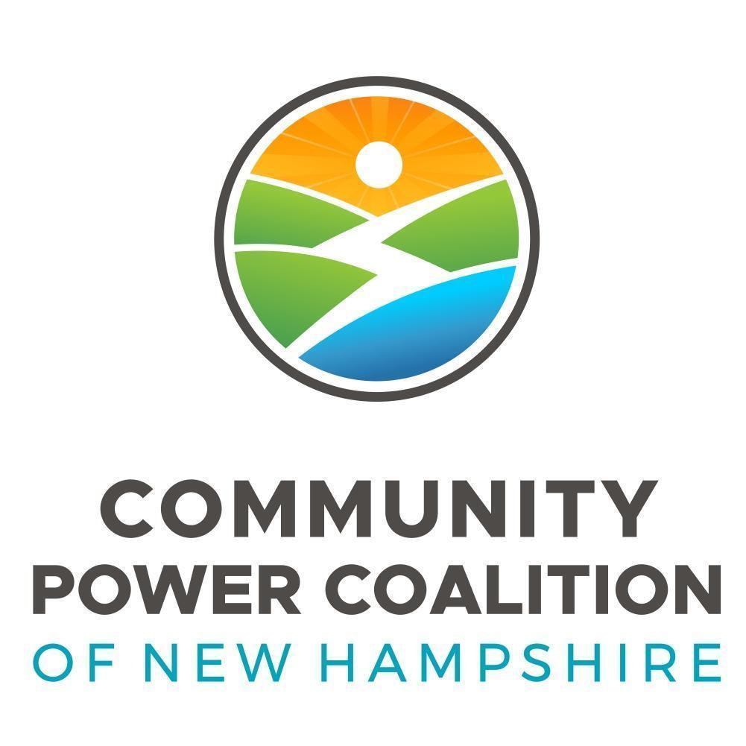 | Governance Committee – minutes
 | Meeting Type: | Regular Meeting
 | Meeting Location: | 12 Court Street (County Hall Building, Commissioners Conference Room) Keene NH
 | Meeting Date: | Monday, November 20, 2023
 | Meeting Time: | 10:15am

Members, attending in person | Members and Others, attending virtually | Members, absent
- Mark Terry, Member Representative, Westmoreland  - Terry Clark, Board Director, Cheshire County | - Committee Member, Joseph Lamattina, Board Director, Newmarket  - Andrew Maneval, Member Representative, Harrisville  - Guest, Clifton Below, Board Chair, Lebanon  - Guest, Brian Callnan, CPCNH CEO  - Guest, Bobbi-Jo Michael, CPCNH Director of Administration | - Committee Chair, Andrea Hodson, Board Director, Harrisville  - April Salas, Board Director, Hanover

Proposed Agenda
- Welcome, Roll Call
- Agenda, 10/16 Minutes
- Board Culture and Effectiveness survey /c
- Other business
- Adjournment

Committee Member, Joseph Lamattina, called the meeting to order and with roll call and in-person quorum established, members unanimously consented to approve the proposed agenda and October 16 meeting minutes.

Committee member Lamattina shared the Board Culture and Effectiveness draft survey with the committee members and guests. The committee first discussed the rating categories and determining how many and what they should be for each question. Overall the committee would like to see the following options for each question: Agree or Disagree with an option for board members to leave a comment.

Committee Member, Maneval, noted that when reviewing the questions in the survey it is important to understand there is a distinction between the terms “takes” and “should take” because we are still a new organization and there may be instances when the board has not been presented with the opportunity to perform the action being considered. In that case “should take” would be appropriate.

Committee Member, Lamattina, suggested that when the survey goes out to the board members there should be a clear message that the questions in the survey reflect how the board is running currently.
The committee started the process of reviewing each question within the survey to determine its relevance to the CPCNH Board of Directors and to work on language edits for each.

Regarding the first question in the survey, the language The roles and responsibilities of our board are clearly defined and separate from those of the staff was approved. This generated a question from Board Director, Clark, as to whether there is a board member’s handbook. Chair Below responded that there is a draft policy for board members and that developing a board policy manual would be a good project for the Governance Committee to work on.
Review of the survey questions continued. There were some edits to the language in questions #5, #8, #9, #11, #14 and #17.

The draft survey is linked here:
https://docs.google.com/spreadsheets/d/1mT58QXl1UmWBnC6dcULjp6ReB5uGKSM8/edit?usp=sharing&ouid=102220830068566547400&rtpof=true&sd=true

The committee paused the review of the survey questions to allow CEO, Callnan, the opportunity to share with the committee that CPCNH is considering moving to a board management software. The software program is OnBoard, and will help provide uniformity with the development and organization around a calendar, board documents such as agendas, meeting materials, minutes etc. The package also provides some self evaluation surveys that can be maintained within the software. The program can help limit the amount of access with permissions which will allow for increased security. If approved, CPCNH would be looking to launch the software program in early 2024.

The next Governance Committee meeting is tentatively scheduled for December 18, 2023 at 10:15 a.m. At the next meeting the committee will continue to review the survey questions beginning with section #4.

Director, Clark, moved to adjourn, Member Representative, Terry, seconded the motion.
Motion passed by unanimous consent without objection.

